

Network Connections Monitor: Live Monitoring and Internal Analysis

21CSE490J – WINDOWS AND LINUX INTERNALS

Mini Project Report

Submitted by

Avanthika ck [RA2312703010003]
M tech Integrated CSE – Cyber Security and Digital Forensics

Adarsh P Abhilash [RA2312703010009]
M tech Integrated CSE – Cyber Security and Digital Forensics

DEPARTMENT OF NETWORKING AND COMMUNICATION SCHOOL OF COMPUTING
COLLEGE OF ENGINEERING AND TECHNOLOGY SRM INSTITUTE OF SCIENCE AND TECHNOLOGY
(Under Section 3 of UGC Act, 1956)
S.R.M. NAGAR, KATTANKULATHUR – 603 203

OCTOBER 2026


SRM INSTITUTE OF SCIENCE AND TECHNOLOGY KATTANKULATHUR – 603 203

BONAFIDE

This is to certify that 21CSC267T – STATISTICS FOR MACHINCE LEARNING, Mini Project titled “Network Connections Monitor: Live Monitoring and Internal Analysis” is the bonafide work of Student Avanthika ck (RA2312703010003), Adarsh P Abhilash (RA2312703010009) who undertook the task of completing the project within the allotted time.

SIGNATURE SIGNATURE

Dr. Priyanga S
Assistant Professor Department of Networking and Communications
SRM Institute of Science and Technology
Dr. Lakshmi M
Professor and Head Department of Networking and Communications
SRM Institute of Science and Technology

TABLE OF CONTENTS

Chapter No. | Title | Page No.
1. | Abstract | 4
2. | Introduction | 5
3. | Objective | 6
4. | Literature Survey | 7
5. | Issues identified | 8
6. | Proposed Work | 9
7. | Modules involved | 11
8. | Module Description | 12
9. | Hardware Components used | 15
10. | Implementation | 16
11. | Results | 18
16. | Appendix – I (Demo screenshots) | 22
17. | Appendix – II (Sample Code) | 24

- Abstract

Every program that communicates over a network does so through sockets, and the operating system keeps a table of all of them: the local and remote address, the port, the state and the process that owns each socket. On a normal Windows or Linux machine this table holds dozens to hundreds of entries, yet users rarely look at it, and the raw output of tools such as netstat gives little help in deciding which entries are ordinary and which deserve attention.
This project presents the Network Connections Monitor, a command-line tool written in Python that reads the operating system’s connection table through the psutil library, attaches the owning process name and PID to every socket, and classifies each remote address as loopback, internal or external. In live mode it shows a dashboard that refreshes every two seconds and reports connections that have opened or closed. In analyze mode it performs an internal analysis of a single snapshot: counts by state and scope, the busiest processes and remote hosts, the listening ports, and rule-based flags for risky external ports, services listening on all interfaces and external links from unidentified processes. Results can be exported as JSON and CSV.
The tool was tested on a Windows system. One scan recorded 110 sockets, of which 32 were established, 26 were external connections and 32 were listening. The tool flagged 23 listeners; most were standard Windows services, while MySQL, VMware, SMB and a third-party server service were identified as items to review. The results show that the tool makes hidden network activity visible and gives a practical starting point for reviewing the security posture of a machine.

2. Introduction

2.1 Background
A socket is the endpoint of a network communication. For TCP, each socket is in a state such as LISTEN (waiting for incoming connections), ESTABLISHED (an active connection), TIME_WAIT (a closed connection whose address is held briefly so that late packets can expire) or SYN_SENT (a connection that is being opened). UDP sockets have no connection state. Every socket belongs to a process, identified by a process ID (PID), and the kernel records this relationship.

2.2 How the operating systems expose connections
On Windows, the TCP and UDP tables are available to programs through the IP Helper API, and the command netstat -ano prints them together with PIDs. On Linux, the kernel publishes the tables in files such as /proc/net/tcp and /proc/net/udp, and the process that owns a socket is found by matching socket inode numbers with the entries under /proc/<pid>/fd; the ss command presents this information. The psutil library hides these differences behind one function, net_connections(), which is the data source used in this project.

2.3 Need for the project
Open ports and unexpected outbound connections are among the first things examined in a security review. A service that listens on all network interfaces can be reached by other devices on the same network, which matters on shared networks such as hostel, college or public Wi-Fi. A tool that shows these facts with context, and keeps showing them as they change, saves the effort of reading raw tables by hand.

2.4 Scope
The tool monitors TCP and UDP sockets over IPv4 and IPv6 on the local machine. It does not capture packets, measure bandwidth or block traffic. The implementation is cross-platform by design, but all results in this report were obtained on Windows.

3. Objective
The aim of the project is to build a lightweight tool that makes the network activity of a computer visible and easy to analyse. The specific objectives are:
- To display active TCP and UDP connections live and refresh them at a user-defined interval.
- To identify the process name and PID that owns each connection.
- To classify each remote address as loopback, internal or external.
- To analyse a snapshot of the connection table and flag risky ports, services listening on all interfaces and unidentified processes with external links.
- To record connection events (NEW and CLOSED) and export snapshots as JSON and CSV for reporting.
- To study how Windows and Linux expose sockets and their owning processes, and to apply this on a real machine.

4.Literature Survey

Several tools already show network connections or network activity. They were studied to understand what is available and what is missing. Table 4.1 summarises them.
Table 4.1: Existing tools for viewing network connections
Tool | Platform | What it does | Limitation for this use case
netstat | Windows, Linux | Lists sockets, states and (with -ano on Windows) owning PIDs. | Raw table; PIDs must be looked up by hand; no scope classification or risk flags; one-time output.
ss | Linux | Fast socket statistics read from the kernel; shows owning processes with -p. | Linux only; no analysis or risk rules.
lsof | Linux, macOS | Lists open files, including network sockets, per process. | Output is large and unsummarised.
TCPView (Sysinternals) | Windows | Graphical view of TCP and UDP endpoints with process names. | Display-oriented; no rule-based analysis or report export of findings.
Resource Monitor | Windows | Shows network activity and listening ports per process. | Interactive only; no flags or export.
Wireshark | Windows, Linux, macOS | Captures and dissects packets. | Heavy for a quick overview of who is connected; needs a capture driver.
Nmap | Cross-platform | Scans a host from outside to find open ports. | Shows ports, not the local processes behind them.
psutil | Cross-platform library | Python interface to system information, including net_connections(). | A library, not a finished tool; used here as the data source.

The existing tools are good at showing data, but each leaves some work to the user: looking up processes, deciding whether an address is local or remote, spotting services that listen on every interface, or noticing short-lived connections. The Network Connections Monitor combines the collection of psutil with address classification, simple security rules and live event tracking in a single script.

5. Issues identified
The following issues were identified in the way connection information is normally viewed and in the data collected during testing:
- Raw output without context. netstat -ano lists addresses and PIDs, but the user must look up each PID and decide whether an address is local or remote.
- No separation of internal and external traffic. Connections to the same machine, to the local network and to the internet appear together.
- Exposed listeners go unnoticed. A service bound to 0.0.0.0 or :: accepts connections on every network interface, which is risky on shared networks.
- Snapshot-only view. A single run cannot show connections that open and close within seconds, such as the short-lived connection captured in Section 11.5.
- Alert noise on Windows. Windows runs many system services that legitimately listen on all interfaces, such as RPC on port 135 and dynamic ports from 49152 upward. A simple rule flags all of them; the first scan produced 23 flags.
- Privilege limits. Without Administrator (Windows) or root (Linux) rights, the owner of some connections cannot be read and the process appears as unknown.
- Hard to keep and share. Screen output cannot easily be stored, compared or attached to a report.

6. Proposed Work

6.1 Overview
The proposed work is a single Python program, netmon.py, that processes the connection table in four steps, as shown in Figure 6.1. It first collects the table with psutil, then enriches each entry with the process name and PID, classifies the remote address as loopback, internal or external, and finally analyses the data and presents it. The presentation is either a live table with NEW and CLOSED events or a one-time analysis that can be exported as JSON and CSV.
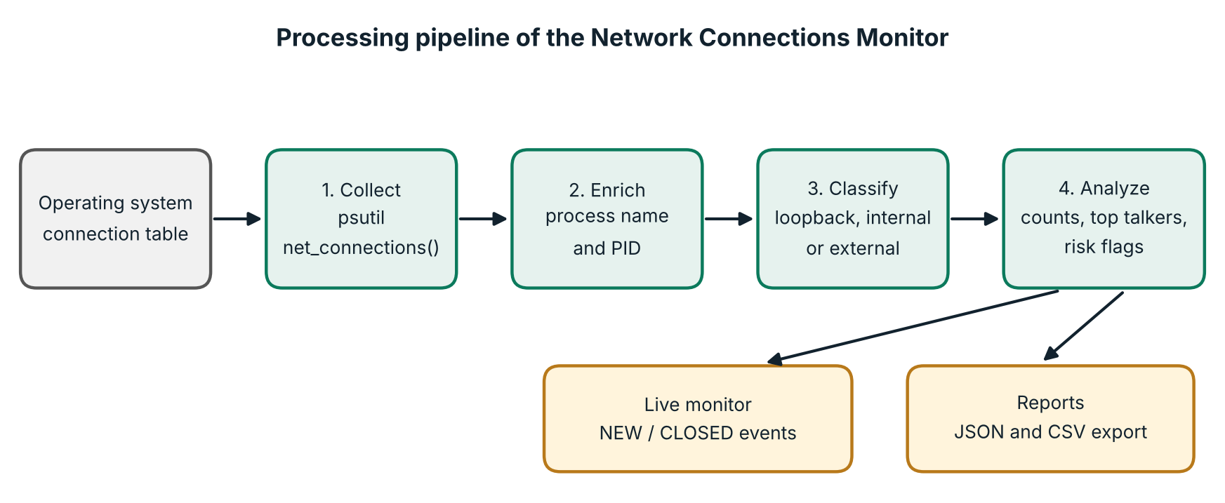
Figure 6.1: Processing pipeline of the Network Connections Monitor

6.2 Operating modes
- analyze: takes one snapshot, prints the summary, flagged items and a table of established connections, and can export the result.
- live: repeats the collection every few seconds, redraws the dashboard, compares each snapshot with the previous one to report NEW and CLOSED connections, and can log these events to a file.

6.3 Address scope classification
Table 6.1: Scope assigned to the remote address
Scope | Condition
loopback | Loopback addresses (127.0.0.0/8 and ::1).
internal | Private ranges (10.x.x.x, 172.16–172.31.x.x, 192.168.x.x), link-local and unspecified addresses.
external | Any other address, that is, a public internet address.
- | No remote address (listening sockets and unconnected UDP sockets).

6.4 Risk rules
Table 6.2: Rules used to flag a connection
Rule | Condition | Reason
R1 | Remote address is external and the remote port is in the risky-port list. | These ports are used by cleartext or remote-control services, or are common in malware (Table 8.1).
R2 | Socket is listening on all interfaces (0.0.0.0 or ::) on a port that is not in the common-services list. | The service can be reached from other devices on the network.
R3 | Remote address is external and the owning process is unknown. | An external link whose owner cannot be identified needs a closer look.

7. Modules involved
The program is organised into eight modules. Each module is implemented as one or more functions in netmon.py (Table 7.1).
Table 7.1: Modules and the functions that implement them
No. | Module | Functions in netmon.py
1 | Data collection | collect()
2 | Process resolver | proc_name()
3 | Address classifier | scope_of()
4 | Risk analyzer | flags_for(), analyze()
5 | Hostname resolver | resolve()
6 | Display | print_summary(), print_table(), fmt_ep()
7 | Live monitor and event log | live(), key(), log_event()
8 | Exporter and command-line interface | export(), main()

8. Module Description

8.1 Data collection
collect() calls psutil.net_connections(kind="inet"), which returns every TCP and UDP socket on the machine. For each socket it builds a record with the protocol, local address and port, remote address and port, state, PID, process name, scope and flags. If the operating system denies access, the program stops with a message asking the user to run it as Administrator or with sudo.

8.2 Process resolver
proc_name() converts a PID into a process name with psutil.Process(pid).name(). Results are stored in a cache so each PID is looked up only once. If the process has ended or access is denied, the name is shown as ?.

8.3 Address classifier
scope_of() uses Python’s ipaddress module to decide whether the remote address is loopback, internal or external (Table 6.1). Sockets without a remote address, such as listening sockets, receive no scope.

8.4 Risk analyzer
flags_for() applies the three rules of Table 6.2 to one connection. analyze() summarises the whole snapshot: the total number of sockets, counts by state and by scope, the five busiest processes and remote hosts among established connections, the listening ports, and the list of flagged connections. The risky-port list used by rule R1 is given in Table 8.1; rule R2 ignores ports in the common-services list (22, 53, 80, 123, 443, 631, 3306, 5432, 6379, 8080, 8443).
Table 8.1: Risky remote ports checked by rule R1
Port | Service or reason
23 | Telnet (cleartext)
139 | NetBIOS
445 | SMB
1337 | Common backdoor port
3389 | Remote Desktop (RDP)
4444 | Metasploit default
5555 | ADB / backdoor
5900 | VNC
6667 | IRC (used by botnet command channels)
31337 | Back Orifice

8.5 Hostname resolver
When the --resolve option is used, resolve() performs reverse DNS lookups. The lookups run in a pool of eight background threads and their results are cached, so a slow DNS server never freezes the display: until a lookup finishes, the plain IP address is shown.

8.6 Display
print_summary() prints the totals, state counts, top processes, top hosts, listening ports and the first ten flagged items. print_table() prints the established connections, with external connections listed first, in coloured columns: process, PID, protocol, local address, remote address, state and scope. Colours are switched off automatically when the output is not a terminal or when the NO_COLOR variable is set.

8.7 Live monitor and event log
live() runs a loop. In each pass it collects the connections, builds a set of keys (protocol, addresses, ports and PID) for the ESTABLISHED and LISTEN sockets, and compares it with the previous pass. Keys that are new are reported as NEW and keys that have disappeared as CLOSED. The last eight events are shown under the table, and log_event() also appends each event with a timestamp to the log file when --log is given. Pressing Ctrl+C stops the loop and writes the final snapshot if an export option was given.

8.8 Exporter and command-line interface
export() writes the snapshot and its analysis to a JSON file, and the list of connections to a CSV file that can be opened in Excel. main() reads the command-line options with argparse and starts the chosen mode (Table 10.1).

9. Hardware Components used
The tool needs no special hardware. It runs on any computer that can run Python 3 and has a network interface. The system used for development and testing is described in Table 9.1, and the software in Table 9.2.
Table 9.1: Hardware used
Component | Details
Computer | HP Pavillion
Processor | Intel core i5
Memory | 8GB
Network interface | Wireless or Ethernet adapter with a private IPv4 address
Display | Terminal window of about 120 columns or wider is recommended

Table 9.2: Software used
Software | Details
Operating system | Windows 11
Language | Python 3.13
Library | psutil ; standard modules socket, ipaddress, argparse, json, csv, concurrent.futures
Terminal | Windows PowerShell (Windows Terminal)
Editor | Visual Studio Code
Applications running during the test | Chrome, Telegram, OneDrive, Edge WebView2, MySQL and VMware services

10. Implementation

10.1 Environment setup
- Install Python 3 from python.org and tick “Add Python to PATH” during installation.
- Create a folder for the project, for example Documents\netmon, and save netmon.py in it.
- Open Windows PowerShell as Administrator and change to the folder with cd Documents\netmon.
- Install the only dependency with pip install psutil.
- Run python netmon.py analyze to test the installation.

10.2 Program structure
The program is a single file of about 250 lines. It begins with two constants: RISKY_PORTS, a dictionary of the ports in Table 8.1, and COMMON_LISTEN, the set of ports that rule R2 ignores. The helper functions follow, then the analysis and display functions, the live loop, and main(). The classification and rule functions are short enough to show in full:
def scope_of(ip):
"""Classify an address as loopback / internal / external."""
if not ip:
return "-"
try:
a = ipaddress.ip_address(ip.split("%")[0])
except ValueError:
return "-"
if a.is_loopback:
return "loopback"
if a.is_private or a.is_link_local or a.is_unspecified:
return "internal"
return "external"

def flags_for(c):
out = []
if c["scope"] == "external" and c["rport"] in RISKY_PORTS:
out.append(f"risky port {c['rport']}: {RISKY_PORTS[c['rport']]}")
if c["status"] == "LISTEN" and c["laddr"] in ("0.0.0.0", "::") \
and c["lport"] not in COMMON_LISTEN:
out.append("listening on all interfaces")
if c["scope"] == "external" and c["proc"] == "?":
out.append("external link, unknown process")
return out
10.3 Algorithm of live mode

- Read the command-line options (interval, row limit, DNS, log file, export files).
- Collect all connections and build the set of keys for ESTABLISHED and LISTEN sockets.
- Compare the set with the previous one; add NEW and CLOSED events and append them to the log if requested.
- Clear the screen; print the summary, the table of established connections and the recent events.
- Wait for the chosen interval and repeat from step 2.
- On Ctrl+C, print “Stopped.” and export the last snapshot if requested.

10.4 Command-line options
Table 10.1: Command-line options of netmon.py
Option | Meaning
analyze | Take one snapshot and print the analysis.
live | Show the live dashboard.
-i, --interval | Refresh interval in seconds (default 2).
-n, --limit | Maximum number of rows in the table (default 20).
--resolve | Show hostnames using reverse DNS.
--log FILE | Append NEW and CLOSED events to a file.
--json FILE, --csv FILE | Export the snapshot as JSON or CSV.

10.5 Windows and Linux compared
The project is built on the same ideas on both systems, but the way each operating system exposes them differs. Table 10.2 compares the points relevant to this tool.
Table 10.2: Connection information on Windows and Linux
Point | Windows | Linux
Source of the socket table | IP Helper API (TCP and UDP tables) | /proc/net/tcp, /proc/net/udp and related files
Owner of a socket | PID stored with each table entry | Socket inode matched with /proc/<pid>/fd
Native command | netstat -ano | ss -tulpn
Rights to see all owners | Administrator | root (sudo)
Typical listeners | RPC (135), SMB (445), dynamic RPC ports from 49152 | For example sshd (22) or a local DNS stub resolver (53)
Used by this tool through | psutil.net_connections() | psutil.net_connections()

11. Results

11.1 Test setup
The tool was run on the Windows system described in Chapter 9. python netmon.py analyze was run in Windows PowerShell, and then python netmon.py live was started and stopped with Ctrl+C. Chrome, Telegram, OneDrive, MySQL and VMware services were running at the time, so the connection table contained a realistic mix of everyday and background activity. The full screenshots are given in Appendix – I; the figures below are close-ups of the relevant parts.

11.2 Summary of the scan
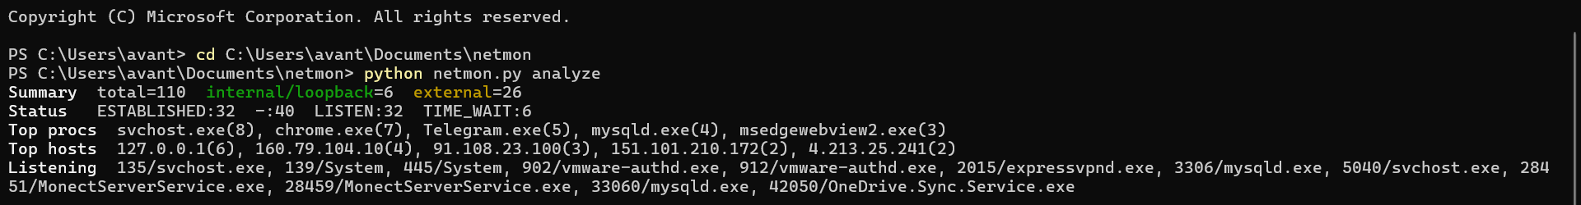
Figure 11.1: Summary printed by analyze mode
Table 11.1: Values reported in the summary
Item | Value
Total sockets | 110
ESTABLISHED / LISTEN / TIME_WAIT / no state (UDP) | 32 / 32 / 6 / 40
Established connections to loopback or internal addresses | 6
Established connections to external addresses | 26
Top processes | svchost.exe (8), chrome.exe (7), Telegram.exe (5), mysqld.exe (4), msedgewebview2.exe (3)
Top remote hosts | 127.0.0.1 (6), 160.79.104.10 (4), 91.108.23.100 (3), 151.101.210.172 (2), 4.213.25.241 (2)

Most established connections go to external addresses, which is normal for a machine with a browser, a messaging application and a cloud-storage client running. The - count of 40 consists of UDP sockets, which have no connection state.

11.3 Flagged listeners
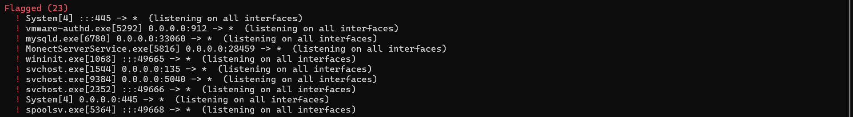
Figure 11.2: Flagged listeners reported by rule R2

The tool flagged 23 items, all by rule R2 (listening on all interfaces). Table 11.2 groups the flagged processes and gives an assessment. The flags are heuristics: they point to services that deserve a look and do not by themselves prove a problem.
Table 11.2: Assessment of the flagged listeners
Process | Ports | Meaning | Assessment
lsass.exe, services.exe, wininit.exe, spoolsv.exe | 49664–49668, 49682 | Windows RPC services on dynamic ports (49152 and above) | Normal
svchost.exe | 135, 5040, 49666 | RPC endpoint mapper and other Windows service listeners | Normal
System (PID 4) | 445 | SMB file sharing, enabled by default on Windows | Review: avoid exposing it on public Wi-Fi
mysqld.exe | 33060 (3306 also listening) | MySQL server ports | Review: bind to 127.0.0.1 if used only locally
vmware-authd.exe | 902, 912 | VMware authorization service | Review: confirm VMware is installed and needed
MonectServerService.exe | 28451, 28459 | Third-party server service | Review: confirm it is expected software

11.4 Established connections
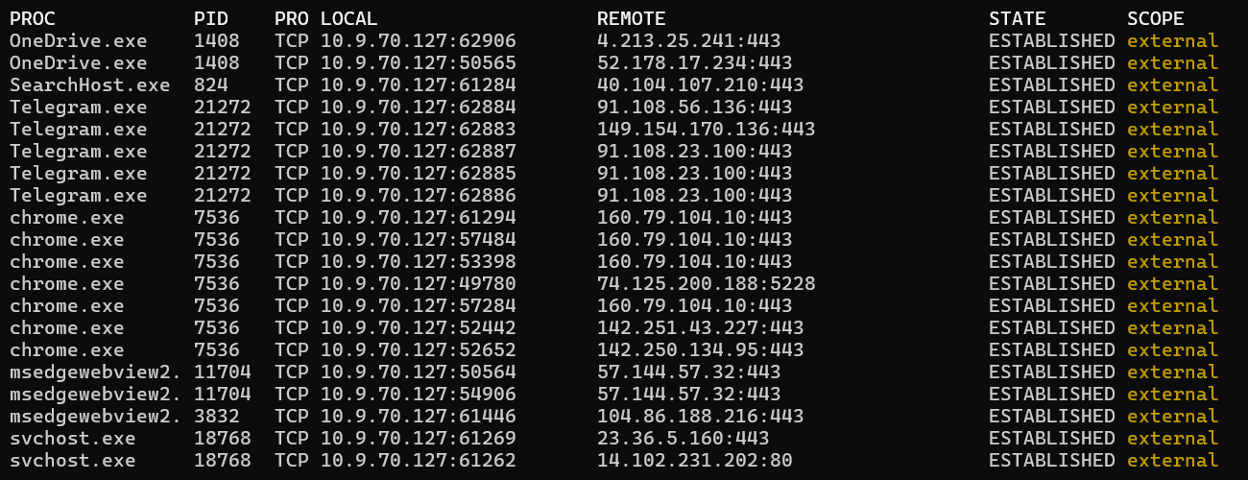
Figure 11.3: Table of established connections (external first)
All connections in the table are to external addresses. Almost all of them use port 443 (HTTPS). Chrome has one connection to port 5228, which is used by Google’s push-notification service, and one svchost.exe connection uses port 80 (plain HTTP). The Telegram connections go to addresses in the ranges that Telegram uses. The table shows which program is behind every connection, something the plain netstat output does not show without extra lookups.

11.5 Live monitoring events
Figure 11.4: NEW and CLOSED events recorded by live mode
While the live monitor was running, it recorded a connection opened by taskhostw.exe (PID 18080) to an external address on port 443 at 09:59:51, which was closed again at 09:59:53. A connection that lasts two seconds would not appear in a single netstat run, which shows that live mode catches short-lived activity.

11.6 Discussion and conclusion
The tool met its objectives. It listed the live connections with their owning processes, separated internal from external traffic, produced a summary and flags, and recorded connection events. The scan showed that the connections of the machine belong to ordinary applications, and it brought out three listener groups worth reviewing: the MySQL ports, the VMware and third-party services, and SMB.
The main limitation is noise on Windows: 23 flags, most of them normal system services. In the future, the tool can be improved with an allow-list of trusted system processes, a severity ranking of flags, a graphical or web dashboard, and alerts or IP geolocation lookups. Testing on Linux, using the same code, is another planned step.

12. Appendix – I (Demo screenshots)
The steps used for the demonstration are listed in Table A.1. Figures A.1 and A.2 show the complete screenshots taken during the run.
Table A.1: Demonstration steps
Step | Action | Expected result
1 | Open Windows PowerShell as Administrator. | Process names are shown instead of ?.
2 | cd Documents\netmon | Prompt moves to the project folder.
3 | python netmon.py analyze | Summary, flagged listeners and table of established connections.
4 | python netmon.py live | Dashboard refreshes every 2 seconds.
5 | Open a new website in Chrome. | A NEW event appears under Recent events.
6 | Press Ctrl+C. | “Stopped.” is printed.
7 | python netmon.py analyze --json out.json --csv out.csv | Report files are written.

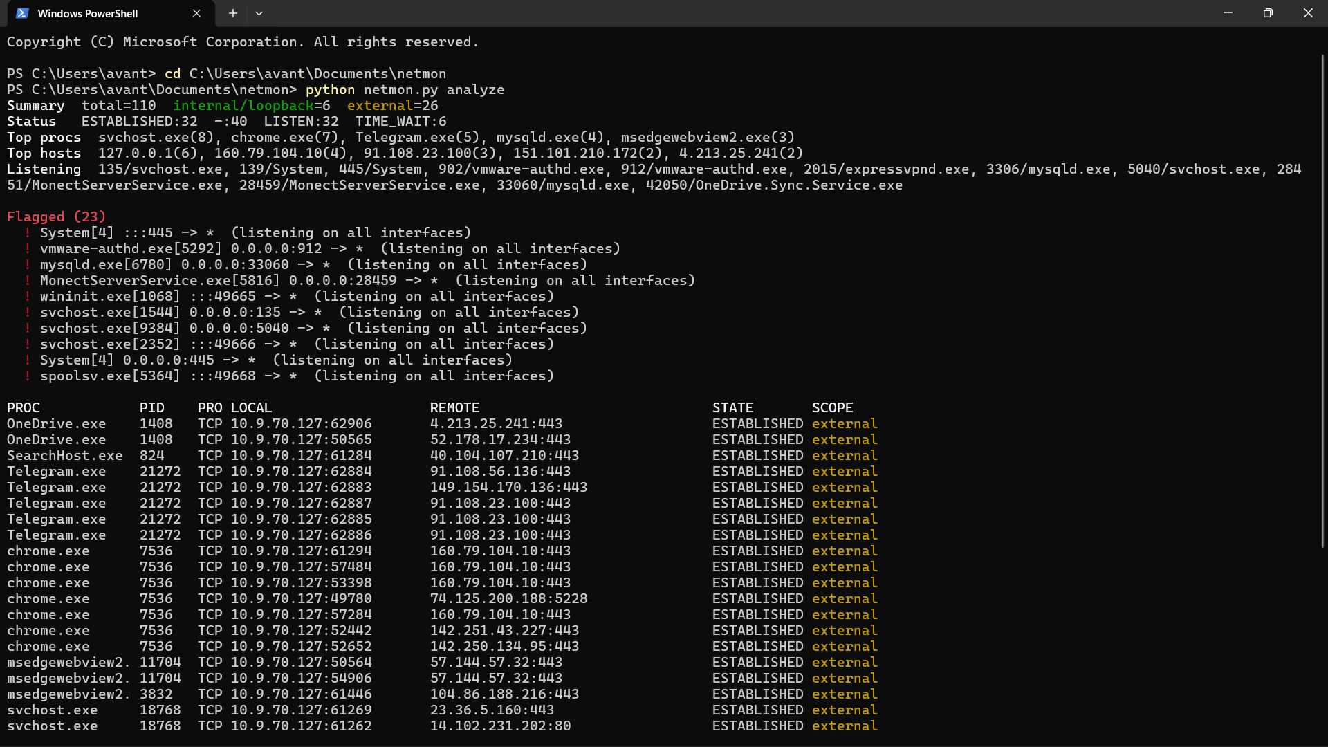
Figure A.1: Complete output of python netmon.py analyze in Windows PowerShell
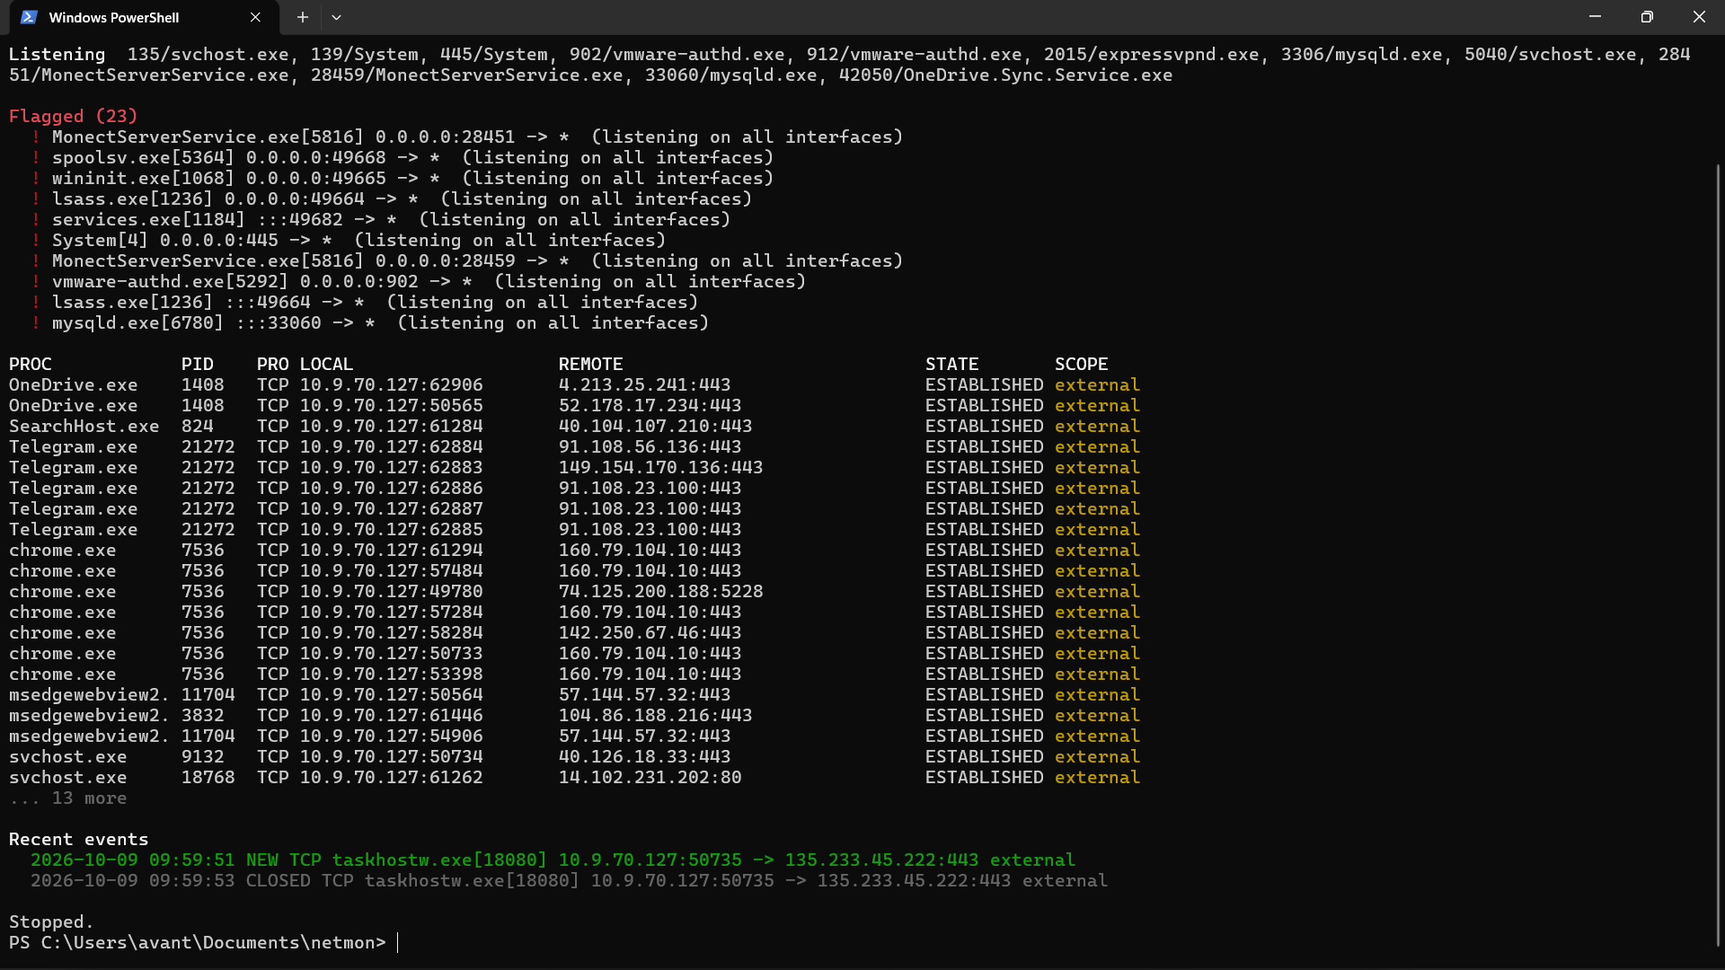
Figure A.2: Output after running live mode, showing the Recent events section

13. Appendix – II (Sample Code)
Complete source code of netmon.py.
#!/usr/bin/env python3
"""
Network Connections Monitor: Live Monitoring and Internal Analysis

Usage:
python netmon.py live # live dashboard (refresh every 2s)
python netmon.py live -i 5 --resolve # slower refresh + reverse DNS
python netmon.py analyze # one-time snapshot analysis
python netmon.py analyze --json out.json --csv out.csv
python netmon.py live --log events.log

Tip: run with sudo/Administrator to see connections of all processes.
Requires: pip install psutil
"""
import argparse, csv, ipaddress, json, os, socket, sys, time
from collections import Counter
from concurrent.futures import ThreadPoolExecutor
from datetime import datetime

try:
import psutil
except ImportError:
sys.exit("psutil is required: pip install psutil")

# Ports that deserve attention when talking to external hosts
RISKY_PORTS = {
23: "Telnet (cleartext)", 1337: "Common backdoor port", 3389: "RDP",
4444: "Metasploit default", 5555: "ADB / backdoor", 5900: "VNC",
6667: "IRC (botnet C2)", 31337: "Back Orifice", 445: "SMB", 139: "NetBIOS",
}
COMMON_LISTEN = {22, 53, 80, 123, 443, 631, 3306, 5432, 6379, 8080, 8443}

R, G, Y, C, B, D, X = ("\033[31m", "\033[32m", "\033[33m", "\033[36m",
"\033[1m", "\033[2m", "\033[0m")
if not sys.stdout.isatty() or os.environ.get("NO_COLOR"):
R = G = Y = C = B = D = X = ""

_proc_cache, _dns_cache = {}, {}
_pool = ThreadPoolExecutor(max_workers=8)

def scope_of(ip):
"""Classify an address as loopback / internal / external."""
if not ip:
return "-"
try:
a = ipaddress.ip_address(ip.split("%")[0])
except ValueError:
return "-"
if a.is_loopback:
return "loopback"
if a.is_private or a.is_link_local or a.is_unspecified:
return "internal"
return "external"

def proc_name(pid):
if pid is None:
return "?"
if pid not in _proc_cache:
try:
_proc_cache[pid] = psutil.Process(pid).name()
except (psutil.NoSuchProcess, psutil.AccessDenied):
_proc_cache[pid] = "?"
return _proc_cache[pid]

def resolve(ip):
"""Non-blocking reverse DNS; returns cached name or the IP itself."""
if ip not in _dns_cache:
_dns_cache[ip] = _pool.submit(
lambda: socket.gethostbyaddr(ip)[0] if ip else ip)
f = _dns_cache[ip]
if f.done():
try:
return f.result()
except Exception:
return ip
return ip

def flags_for(c):
out = []
if c["scope"] == "external" and c["rport"] in RISKY_PORTS:
out.append(f"risky port {c['rport']}: {RISKY_PORTS[c['rport']]}")
if c["status"] == "LISTEN" and c["laddr"] in ("0.0.0.0", "::") \
and c["lport"] not in COMMON_LISTEN:
out.append("listening on all interfaces")
if c["scope"] == "external" and c["proc"] == "?":
out.append("external link, unknown process")
return out

def collect():
"""Return list of connection dicts."""
conns = []
try:
raw = psutil.net_connections(kind="inet")
except psutil.AccessDenied:
sys.exit("Access denied. Re-run with sudo / as Administrator.")
for c in raw:
laddr = c.laddr.ip if c.laddr else ""
lport = c.laddr.port if c.laddr else 0
raddr = c.raddr.ip if c.raddr else ""
rport = c.raddr.port if c.raddr else 0
d = {
"proto": "TCP" if c.type == socket.SOCK_STREAM else "UDP",
"laddr": laddr, "lport": lport, "raddr": raddr, "rport": rport,
"status": c.status if c.status != "NONE" else "-",
"pid": c.pid, "proc": proc_name(c.pid), "scope": scope_of(raddr),
}
d["flags"] = flags_for(d)
conns.append(d)
return conns

def key(c):
return (c["proto"], c["laddr"], c["lport"], c["raddr"], c["rport"], c["pid"])

def analyze(conns):
est = [c for c in conns if c["status"] == "ESTABLISHED"]
return {
"timestamp": datetime.now().isoformat(timespec="seconds"),
"total": len(conns),
"by_status": dict(Counter(c["status"] for c in conns)),
"by_scope": dict(Counter(c["scope"] for c in est)),
"top_processes": Counter(c["proc"] for c in est).most_common(5),
"top_remote_hosts": Counter(c["raddr"] for c in est).most_common(5),
"listening": sorted({(c["lport"], c["proc"]) for c in conns
if c["status"] == "LISTEN"}),
"flagged": [c for c in conns if c["flags"]],
}

def fmt_ep(ip, port):
return f"{ip}:{port}" if ip else "*"

def print_summary(a, resolve_dns=False):
print(f"{B}Summary{X} total={a['total']} "
f"{G}internal/loopback{X}="
f"{a['by_scope'].get('internal', 0) + a['by_scope'].get('loopback', 0)} "
f"{Y}external{X}={a['by_scope'].get('external', 0)}")
print(f"{B}Status{X} " + " ".join(f"{k}:{v}" for k, v in a["by_status"].items()))
print(f"{B}Top procs{X} " + ", ".join(f"{n}({c})" for n, c in a["top_processes"]))
hosts = [(resolve(h) if resolve_dns else h, c) for h, c in a["top_remote_hosts"]]
print(f"{B}Top hosts{X} " + ", ".join(f"{h}({c})" for h, c in hosts))
ports = ", ".join(f"{p}/{n}" for p, n in a["listening"][:12])
print(f"{B}Listening{X} {ports or 'none'}")
if a["flagged"]:
print(f"\n{R}{B}Flagged ({len(a['flagged'])}){X}")
for c in a["flagged"][:10]:
print(f" {R}!{X} {c['proc']}[{c['pid']}] {fmt_ep(c['laddr'], c['lport'])} "
f"-> {fmt_ep(c['raddr'], c['rport'])} ({'; '.join(c['flags'])})")

def print_table(conns, limit, resolve_dns):
print(f"{B}{'PROC':<16}{'PID':<7}{'PRO':<4}{'LOCAL':<24}{'REMOTE':<34}{'STATE':<12}SCOPE{X}")
rows = sorted((c for c in conns if c["status"] == "ESTABLISHED"),
key=lambda c: (c["scope"] != "external", c["proc"]))
for c in rows[:limit]:
remote = resolve(c["raddr"]) if resolve_dns else c["raddr"]
remote = fmt_ep(remote, c["rport"])
col = {"external": Y, "internal": C}.get(c["scope"], D)
warn = R if c["flags"] else ""
print(f"{warn}{c['proc'][:15]:<16}{str(c['pid'] or '-'):<7}{c['proto']:<4}"
f"{fmt_ep(c['laddr'], c['lport'])[:23]:<24}{remote[:33]:<34}"
f"{c['status']:<12}{X}{col}{c['scope']}{X}")
if len(rows) > limit:
print(f"{D}... {len(rows) - limit} more{X}")

def export(conns, a, json_path=None, csv_path=None):
if json_path:
with open(json_path, "w") as f:
json.dump({"analysis": a, "connections": conns}, f, indent=2, default=list)
print(f"Saved {json_path}")
if csv_path:
with open(csv_path, "w", newline="") as f:
w = csv.DictWriter(f, fieldnames=list(conns[0].keys()) if conns else ["empty"])
w.writeheader()
for c in conns:
w.writerow({**c, "flags": "; ".join(c["flags"])})
print(f"Saved {csv_path}")

def log_event(path, kind, c):
line = (f"{datetime.now():%Y-%m-%d %H:%M:%S} {kind} {c['proto']} {c['proc']}[{c['pid']}] "
f"{fmt_ep(c['laddr'], c['lport'])} -> {fmt_ep(c['raddr'], c['rport'])} "
f"{c['scope']} {'; '.join(c['flags'])}")
if path:
with open(path, "a") as f:
f.write(line + "\n")
return line

def live(args):
prev, events = {}, []
last = []
try:
while True:
conns = collect()
last = conns
cur = {key(c): c for c in conns if c["status"] in ("ESTABLISHED", "LISTEN")}
if prev:
for k, c in cur.items():
if k not in prev:
events.append((G, "NEW ", log_event(args.log, "NEW", c)))
for k, c in prev.items():
if k not in cur:
events.append((D, "CLOSED", log_event(args.log, "CLOSED", c)))
prev = cur
events = events[-8:]
a = analyze(conns)
os.system("cls" if os.name == "nt" else "clear")
print(f"{B}NETWORK CONNECTIONS MONITOR{X} {datetime.now():%H:%M:%S} "
f"(every {args.interval}s, Ctrl+C to stop)\n")
print_summary(a, args.resolve)
print()
print_table(conns, args.limit, args.resolve)
print(f"\n{B}Recent events{X}")
for col, _, line in events or [(D, "", "none yet")]:
print(f" {col}{line[:110]}{X}")
time.sleep(args.interval)
except KeyboardInterrupt:
print("\nStopped.")
if last:
export(last, analyze(last), args.json, args.csv)

def main():
p = argparse.ArgumentParser(description="Network connections monitor")
p.add_argument("mode", choices=["live", "analyze"])
p.add_argument("-i", "--interval", type=float, default=2.0)
p.add_argument("-n", "--limit", type=int, default=20, help="max table rows")
p.add_argument("--resolve", action="store_true", help="reverse DNS lookups")
p.add_argument("--log", help="append connection events to this file")
p.add_argument("--json", help="export snapshot as JSON")
p.add_argument("--csv", help="export snapshot as CSV")
args = p.parse_args()

if args.mode == "live":
live(args)
else:
conns = collect()
a = analyze(conns)
print_summary(a, args.resolve)
print()
print_table(conns, args.limit, args.resolve)
export(conns, a, args.json, args.csv)

if __name__ == "__main__":
main()

